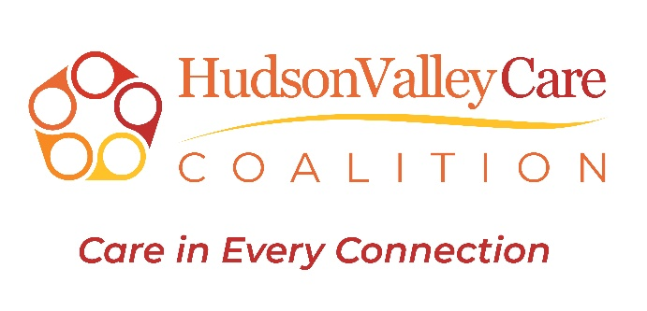

Social Care Navigator Script
Quick Hit (20–30 seconds)
- The Social Care Network is a new, free program for people on Medicaid Managed Care plans in New York.
- It connects you to services that go beyond medical care — like food, housing, transportation, and more — so you can stay healthy.
- With your permission, we’ll see what you need, connect you to local resources, and follow up to make sure you’re getting help.
- Everything is private, and you can stop anytime.
Would you like to see what support is available for you today?
____________________________________________________________
Greetings & Introduction
Hi, my name is [Name], and I’m a Social Care Navigator with [Organization Name]. I’m calling because you may qualify for additional resources and help you connect to services that can support your health and well-being.
Do you have 15-20 minutes, I’d like to tell you about a new program in New York that provides non-medical transportation, food and nutrition resources, and housing supports to Medicaid Members that qualify.

Step 1 – What It Is
The program is a statewide system that connects Medicaid members, like you, to both health care services and community resources that address things that affect your health — like food, housing, transportation, and more. The idea is that your health isn’t just about doctor visits. It’s also about the things in your life that make it easier or harder to stay healthy.

Step 2 – What We Do Together
Here’s how it works:
- First, we will talk about your needs, there are about 13 questions — for example, if you’re having trouble affording healthy food, paying for your rent and utilities, or getting to your non-medical appointments such as going to Social Services to apply for SNAP benefits.
- With your permission, we’ll enter your information into a secure system.
- Second, if you have an unmet need, we will then ask a few additional questions to find out what resources you are qualified to get
- Then We’ll connect you to local programs and resources that can help.
- We’ll check back with you to see how things are going and make adjustments if needed.

Step 4 – Privacy & Choice
Everything we do is your choice. We only share your information with programs or providers you agree to, and your information is kept private and secure.
You can stop participating at any time.

Step 5 – Call to Action
This program is free for Medicaid members, and it’s meant to make your life a little easier.
Would you like to get started today so we can see what resources might be helpful for you?
Key Talking Points for Navigators
FREE | No cost to people on Medicaid Managed Care plans.
Whole-Person Care | Supports needs beyond medical visits — food, housing, transportation, utilities, etc.
Coordinated Help | Connects health care providers and community programs.
Privacy First | Share information only with permission.
Voluntary | Members can start or stop at any time.
Follow-Up | The navigator checks in to ensure services are received.

NYHER Social Care Network – Longer Version

How We Can Help
(For people on Medicaid Managed Care plans)
The Social Care Network is here to help with everyday needs that can affect your health.
It’s free, and you choose what help you want.

1. Food Help
We can connect you to:
- Food pantries or meal delivery
- Grocery store gift cards or farmers’ market coupons
- Nutrition classes or programs to help you eat healthy

2. Housing Help
We can help you:
- Find a safe, stable place to live
- Get help if you’re behind on rent or facing eviction
- Connect to programs for home repairs or safety updates

3. Non-Medical Transportation Help
We can arrange rides for things like:
- Going to the grocery store or food pantry
- Attending support groups or community programs
- Getting to a job interview or other health-related needs

4. Money & Bills Help
We can connect you to:
- Utility bill assistance
- Benefits programs that may give you extra income or support
- Job training or employment help

5. Health & Wellness Support
We can link you with:
- Stress and mental health support
- Help to quit smoking or substance use
- Exercise, walking, or fitness programs in your community

6. Care Coordination
We help make sure:
- Your doctors, social workers, and community programs work together
- You have one main contact to help guide you through the system
Navigator Quick Reminder:
- Always mention it’s free for people on Medicaid Managed Care plans.
- Share 1–2 examples based on what the person just told you they need.
- Keep it friendly, and remind them they can say yes or no to any service.

NYHER Social Care Network – Shorter version on Types of Help Available
(For people on Medicaid Managed Care plans)
The Social Care Network can help with more than just doctor visits.
Here are the main kinds of support:
- Food Help – connecting you to food pantries, grocery cards, meal delivery, or programs that help you get healthy food.
- Housing Help – finding a safe place to live, preventing eviction, or getting help with housing repairs.
- Transportation Help – rides to non-medical appointments connecting you health-related social needs.
- Money & Bills Help – help with utility bills, finding financial assistance programs, or connecting to job support.
- Health & Wellness Support – things like stress management, fitness programs, quitting smoking, or finding a counselor.
- Care Coordination – making sure your doctors, social workers, and community programs work together so you get the help you need.
Key Points for Navigators to Say:
- “This program is free for people on Medicaid Managed Care plans.”
- “It’s meant to help with things in your life that affect your health.”
- “You choose what help you want, and your information stays private.”

